Methocel Delivery System

Adriaan Riet

Sean Lawry

Austin Smith

October 7, 2014



Table of Contents

Tables and Figures ii

Abstract 1

Introduction 1

Apparatus Design 1

Experimental Procedure 2

Safety 2

Theory and Data 2

Results 4

Data Collection 4

Data Analysis 5

Sources of Error 7

Conclusions & Recommendations 8

Appendix 9

Acknowledgements 9

References 10

## Tables and Figures

|  |  |  |
| --- | --- | --- |
| **Tables** | | |
| 1 | *Final Calculations* | *Pg. 4* |
| 2 | *Linear regression for ln(τ) vs. ln(v)* | *Pg. 5* |
| 3 | *Linear regression for (ln(τ)-* *Ω) vs. ln(v)* | *Pg. 6* |

|  |  |  |
| --- | --- | --- |
| **Figures** | | |
| 1 | *Apparatus Design* | *Pg. 2* |
| 2 | *Confidence Intervals* | *Pg. 6* |
| 3 | *Plot of Residuals* | *Pg. 7* |

## Abstract

Methocel, a non-Newtonian fluid, is to be pumped from a railway terminal to a nearby plant. A delivery system is already in place, but must be adequate to transport the fluid without exceeding the rupture disk pressure rating (250 psig). An apparatus has been constructed to measure the flow rate and pressure drop of methocel. This apparatus yielded rheological data which was used to determine the adequacy of the transport system. A pressure drop of 81 psig was calculated, which is well below the 250 psig pressure rating.

## Introduction

Methocel must be transported to a new plant from the nearby railway terminal. A delivery system is already in place, and the objective is to determine if it can transport 75 gallons per minute of a 1% (by weight) methocel solution without exceeding the rupture disk pressure rating (250 psig). The company lab contains a system designed to measure flow rate and pressure drop of the methocel solution in two different pipe sizes. The test system can be used to determine the rheology of the fluid, which can then be used to determine the pressure drop of the system in place. DOW Chemical lists methocel as a pseudoplastic fluid that follows the power law model [Source 1]. This model and the data from the apparatus can be been used to determine the rheological parameters n and K (discussed later) of methocel, as well as the pressure drop in the pipe. The pressure drop through the pipe is equivalent to the minimum required pressure at one end of the existing transport system. If the minimum pressure exceeds the rupture disk rating, a new transport system must be designed. The behavior of methocel solution vs. pure water will also be compared.

## Apparatus Design

A large tank with two mixers keeps the 1% methocel solution well-mixed. A computer controlled valve maintains a constant flow rate, and a second valve switches between the two pipe sizes. Each of these copper pipes have two pressure transducers that measure pressure drop as a function of distance. The pressure drop and flow rate data are then recorded by a computer. The computer is set to record one measurement per second for 100 seconds. Figure 1 is a diagram of the apparatus.

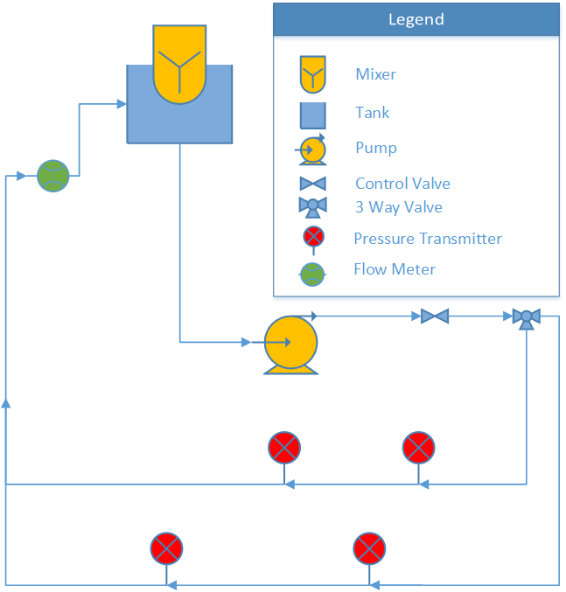

**Figure 1**- *Apparatus Design*

## Experimental Procedure

The experiment was performed in two pipes of different diameters at ten different flow rates in each pipe. Performing the experiment in two separate pipes allowed error to be reduced. Each flow rate experiment had 100 measurements taken at one-second intervals. Randomized experiments minimized any systematic disturbances. Measured variables included the pressure drop across the active pipe, flow rate, the time the reading was taken, pressure drop across the inactive pipe, ambient temperature, ambient pressure, flow set point and the valve controller output.

## Safety

The equipment of the experiment posed potential hazards. There were mixers mixing the solution throughout the lab period and a pump was used to transport the fluid. To avoid problems, one of the team members was always observing the tank while the system was running. This was to ensure others would not come into contact with any of the equipment. The pump was turned off as soon as the data collection was completed. The valve that changed the flow from the large to small diameter pipe needed to be switched when the pump was off. Because fluids were involved in this experiment, care was taken to minimize any potential electrical hazard. Methocel in solution is not particularly hazardous, but is flammable as a powder. The flammability hazard was low since the experimental material was methocel in solution.

## Theory and Data

It is assumed that methocel is a power law fluid. According to notes by Lignell [Source 2], if a fluid follows the power law it will obey Equation 1:

|  |  |  |
| --- | --- | --- |
|  | $τ={K(-\frac{dv}{dr})}^{n}$ | (1) |

where $τ$ is shear stress, $K$ and $n$ are empirically determined constants, and $\frac{dv}{dr}$ is the change in velocity per change in radial distance. $τ$ is calculated using Equation 2.

|  |  |  |
| --- | --- | --- |
|  | $$τ= -\frac{R}{2}\frac{dP}{dx}$$ | (2) |

Equation 2 requires the pressure drop (*dP/dx*) and pipe radius (R), both of which are measured. In order to determine $n$ and $K$, Equation 3 was used. Equations 4 is defined for simplicity.

|  |  |  |  |  |
| --- | --- | --- | --- | --- |
|  | $$\ln{(τ})=n\ln{(v})+\{\ln{(K})+n\ln{(\frac{2(3n+1)}{nD}})\}$$ | | | (3) |
|  | | $$Ω=n ln(\frac{2\left(3n+1\right)}{nD})$$ | (4) | |

By a linear regression of Equation 3, $n$ and $K$ were determined. More details on $Ω$ and the regression will be provided in the data analysis section.

The friction factor $f$, which depends on n and K, was calculated with a modified Reynolds number (Equation 5a) and Equation 5b. The chart is shown in Figure 2.

|  |  |  |
| --- | --- | --- |
|  | $$Re=\frac{8ρv^{2}}{K}(\frac{nD}{2(3n+1)v})^{n}$$ $$f=\frac{64}{Re} (laminar)$$ | (5a)  (5b) |

Equation 6 models pressure drop due to friction in a circular pipe without minor losses.

|  |  |  |
| --- | --- | --- |
|  | $$ΔP=\frac{-fρLv^{2}}{2D}$$ | (6) |

where P is pressure, f is the Darcy friction factor, L is the length of the pipe, v is average velocity through the pipe, and D is the inner diameter of the pipe.

In a system using water, the Reynolds number and friction factor are given by Equations 7 and 8 [Source 4].

|  |  |  |
| --- | --- | --- |
|  | $$Re=\frac{ρvD}{μ},$$ | (7) |

|  |  |  |
| --- | --- | --- |
|  | (turbulent) | (8) |

Once $f$ was acquired for water from Equations 7 and 8, an estimate of the pressure drop was obtained with Equations 6.

## Results

The flow behavior index (n) determines the fluid classification. Newtonian fluids have n=1, and pseudoplastic fluids have n<1. These fluids act differently under shear stress. Pseudoplastic fluids experience a decrease in viscosity with increasing shear stress. The calculated n value of 1% methocel was determined to be about 0.64 in this experiment. The calculated pressure drop through experimentation was 81.4 psig (Table 1), which is less than the maximum pressure of 250 psig. The pressure drop of water running through the same piping system was calculated at 26 psig.

**Table 1:** *Final Calculations*

|  |  |  |  |  |  |  |
| --- | --- | --- | --- | --- | --- | --- |
|  | n | K | Re | f | dP (Pascals) | dP (psig) |
| **small pipe** | 0.59 | 1.21 | 950 | 0.07 | 5.61E+05 | 81.3 |
| **large pipe** | 0.70 | 0.69 | 896 | 0.07 | 5.94E+05 | 86.2 |
| **weighted average** | 0.64 | 0.89 | 949 | 0.07 | 5.61E+05 | 81.4 |

## Data Collection

Measurements from each pipe were grouped together. For every data point, pressure drop per length of pipe was calculated from the measured pressure drop (transducer) and the measured distance (measuring tape) between the pressure sensing probes. To determine pipe diameter, the pipe circumference was measured and converted to an outside diameter. This was referenced with literature to obtain the inner diameter of the pipe (which is the diameter used in all referenced equations) [Source 3]. For each data point, an average fluid velocity was calculated from the measured flow rate and the inner pipe diameter. Shear stress was calculated using Equation (2) and the calculated pressure drop per length of pipe.

## Data Analysis

With this information, ln(τ) (where τ is shear stress) and ln(v) (where v is avg. velocity) were calculated. The large and small diameter pipe n and K values (in Table 1) were calculated with this method.

Linear regressions were performed on ln(τ) vs. ln(v) (in the form of Equation 3) as shown in Table 2. The slope of the regressed line was taken to be a measured value of n. The measured value of n was used to calculate Ω (defined in Equation 4). Once Ω was known, K could easily be calculated from the intercept of the graph. In this manner, K and n values were calculated for both pipes. For convenience, Equation 4 is repeated here.

|  |  |  |
| --- | --- | --- |
|  | $$Ω=n\ln\left(\frac{2\left(3n+1\right)}{nD}\right)$$ | (4) |

**Table 2:** *Linear regression for ln(τ) vs. ln(v)*

|  |  |  |  |
| --- | --- | --- | --- |
| $$y$$ | $$m$$ | $$x$$ | $$b$$ |
| $$ln(τ)$$ | $$n$$ | $$ln(v)$$ | $ln\left(K\right)+$ Ω |

Another linear regression (Table 3) was performed to reconcile the data on the assumption that the true n and K values were the same for the fluid in both pipes (which should be true for a power law fluid.) In order to do this, a linear regression of (ln(τ) – Ω) vs. ln(v) was used instead of the original in order to use all of the data as a whole. This allowed all of the data to be taken together without offset.

To obtain Ω, the pipe diameter corresponding to each data point was used, and n was calculated iteratively. The weighted average of Table 1 was calculated using this method. The Reynolds numbers were also calculated once values of n and K were known. The Reynolds numbers for various flows in the small pipe ranged between 280 and 920, while the large pipe had Reynolds numbers between 115 and 400.

The confidence intervals are quite narrow, especially around the area of interest. Confidence intervals were plotted in Figure 3, and residuals were plotted in Figure 4.

**Table 3:** *Linear regression for (ln(τ)-* *Ω) vs. ln(v)*

|  |  |  |  |
| --- | --- | --- | --- |
| $$y$$ | $$m$$ | $$x$$ | $$b$$ |
| $ln\left(τ\right)-Ω$ | $$n$$ | $$ln(v)$$ | $$ln\left(K\right)$$ |
|  | | | |

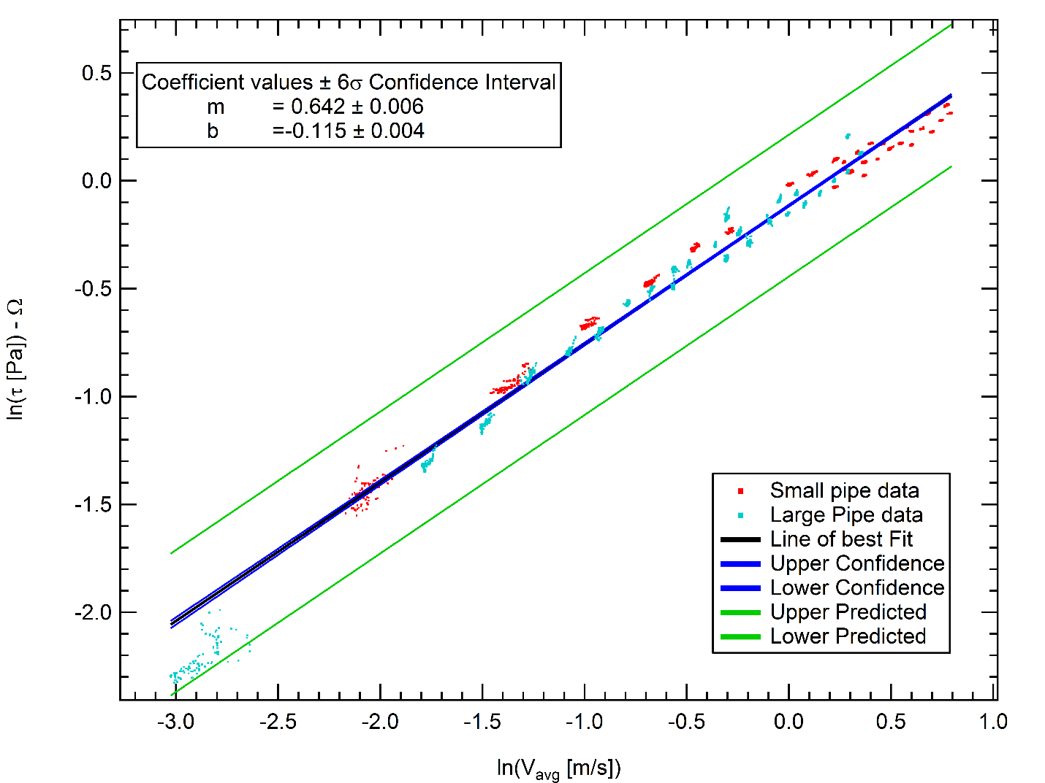

**Figure 2:** *Confidence Intervals*

**Figure 3:** *Plot of Residuals*

There was some initial concern about the cluster of data in the bottom left of both the confidence and residual plots (Figures 2 and 3). These points correspond to very low flow rates in the large pipe. The data was taken to ensure that the pressure/shear relation went to zero in the limit of no flow, and was taken at a much lower flow rate than the rest of the data. Errors here are magnified due to the nature of logarithms.

## Sources of Error

The data showed high levels of confidence in the measured results. However, the experiment did have some sources of error. The main sources of error came from the measurement devices used. One pressure transducer was measuring a slight pressure drop even without flow. The smaller pipe was slightly bowed, due to a table being pushed up against it. The flow rate being controlled by the valve also was not perfectly constant. This could add some error to the calculations. There are also possible errors due to the pipes having a different roughness. These each should be small, but contribute to the error that was seen in the results.

The projected Reynolds number for the existing system (not the lab apparatus) at the specified flow rate (75 gpm) would be about 950. It would be better to operate the test at Reynolds numbers around this value, but the pump in the test apparatus is unable to push flow rates high enough to do that in either pipe. This is unfortunate, but not catastrophic, as the flow is still projected to be laminar. Even turbulence should tend to decrease shear since the fluid is pseudoplastic.

## Conclusions & Recommendations

The pipeline in place can transport methocel to the plant. The pressure drop of methocel in the current piping system is 81.4 psig, while the system can maintain up to 250psig. Figure 3 shows that the data had a high level of confidence. Methocel had a measured n value of 0.64 which confirmed that it is a pseudoplastic fluid. Methocel is expected to run through the pipe with about three times the pressure drop of water. This is within the specifications of the existing pipeline. No new pipeline system is necessary.

## Appendix

|  |  |
| --- | --- |
| D | Pipe inner diameter |
| f | Friction factor |
| K | Non-Newtonian experimental constant |
| L | Length of installed pipe |
| n | Non-Newtonian experimental constant |
| P | Pressure |
| R | Pipe inner radius |
| ρ | Density |
| Re | Reynold’s number |
| τ | Shear stress |
| v | Average velocity |
| x | Position of pressure transducer |
| v | Viscosity |
| Ω | Defined in Equation 4 |

## Acknowledgements

A special thanks to acknowledge Troy Holland, Kevin, Kyle, Tim and Colton for their excellent critiques of this paper.

## References

1. Dow Chemical Company. “METHOCEL Cellulose Ethers.” *Technical Handbook*. Sept. 2012: 16.
2. Lignell, David. “NonNewtonian Fluids.” Fluid Mechanics Lecture. Provo, UT
3. “Copper Tubes – ASTM B88.” http://www.engineeringtoolbox.com/astm-copper-tubes-d_779.html. Accessed Sept. 2014.
4. Engel, Yunus A., and John M. Cimbala. Fluid Mechanics: Fundamentals and Applications. Third ed. 2014. Print.